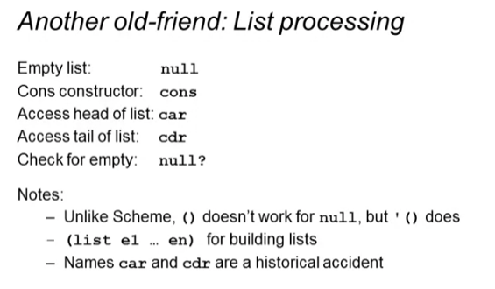

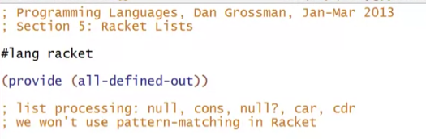

* In racket, the convention is separate words using “-“

Example definition:

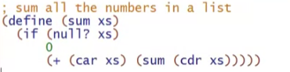

Example invoking:



This will compile but will have a runtime error

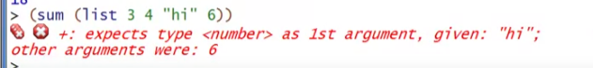

Other example definitions

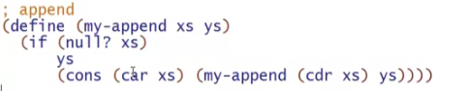



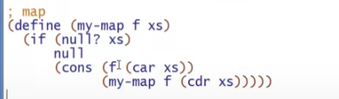





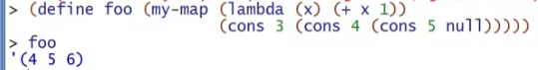

Printing list: ‘(elements)

